Wireless Networks while at Stanford

While in the Residences:

Please use the STANFORD VISITOR network. No log in required. This is great for browsing and email. (Note, you will not see ‘STANFORD’ as an option in the residences!)

While at LASI in CERAS and breakout rooms:

Please log in to the Stanford network as detailed here:

WiFi Guest LogIn and Password:

Select ‘Stanford’ as the wireless network you wish to connect to and when prompted click on ‘Continue to Registration Choices’

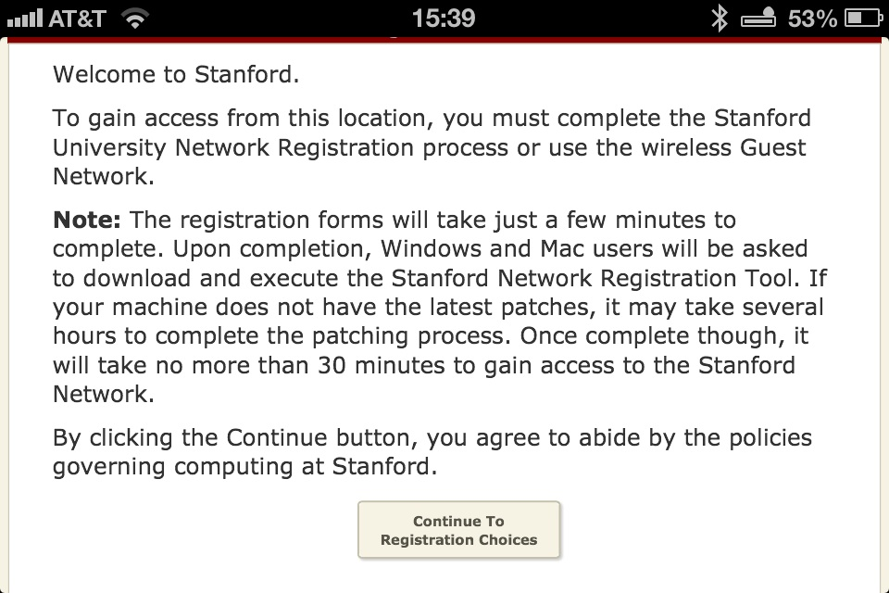

Then, choose 'Wireless Guest',

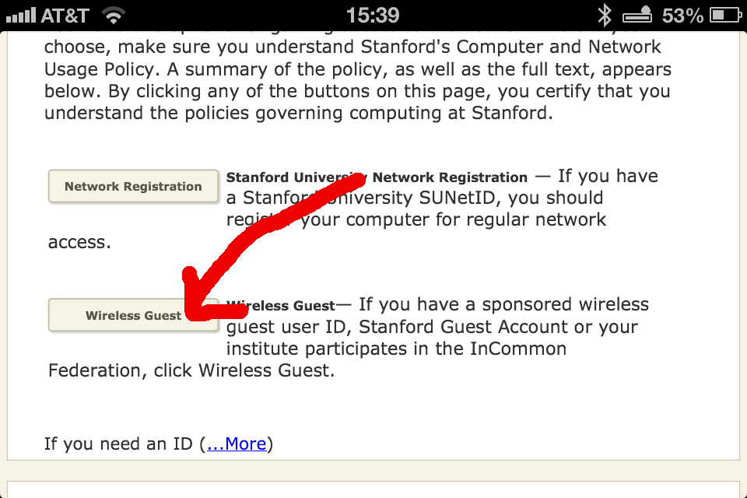

then ‘Guest Network Access’.

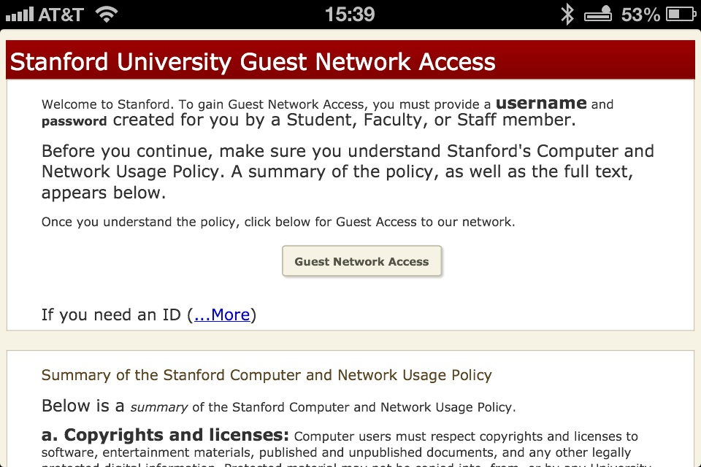

You should then be asked for a user name and password:

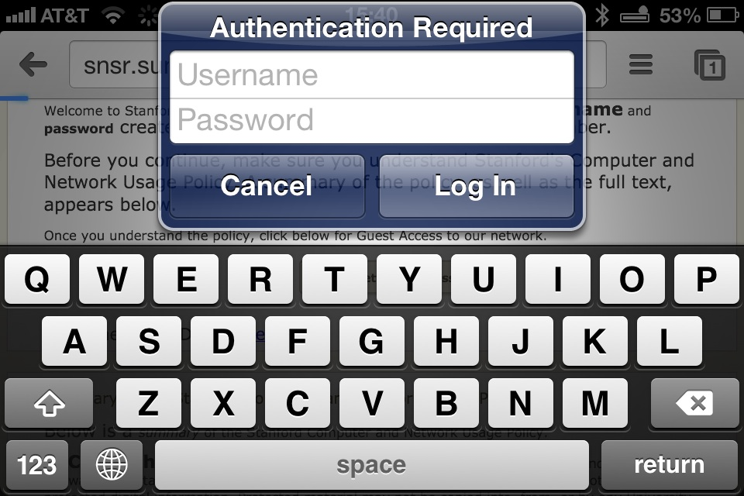

User Name - LASI2013
Password - lasi2013

User name is caps, password is lower case.

NOTE: The first time you log in you may have to go through a verification process by providing information about your computer (model, operating system, questions re ownership and accessing restricted data)

Finally, you should see:

